**Project Two README**

**Joseph Veneski**

**10/15/2023**

**About the Project:**

The aim of this project is to create a NoSQL database with a client-facing web application for use by the client Grazioso Salvare. The MVC design pattern is used for this project to create the web application. The database is created using MongoDB with a Python module for CRUD functionality for the Model component. Dashboard coded using Dash framework to implement interactive filters and visualizations such as geolocation and pie charts for the View and Controller components.

The client logo is displayed at the top of the dashboard, drop down filters below allows users to choose from three custom filtering queries and reset to default option. Geolocation and pie-chart components are interactive with dashboard filters. Tooltip set to display animal name in geolocation chart.

**Mountain or Wilderness Rescue Filter:**

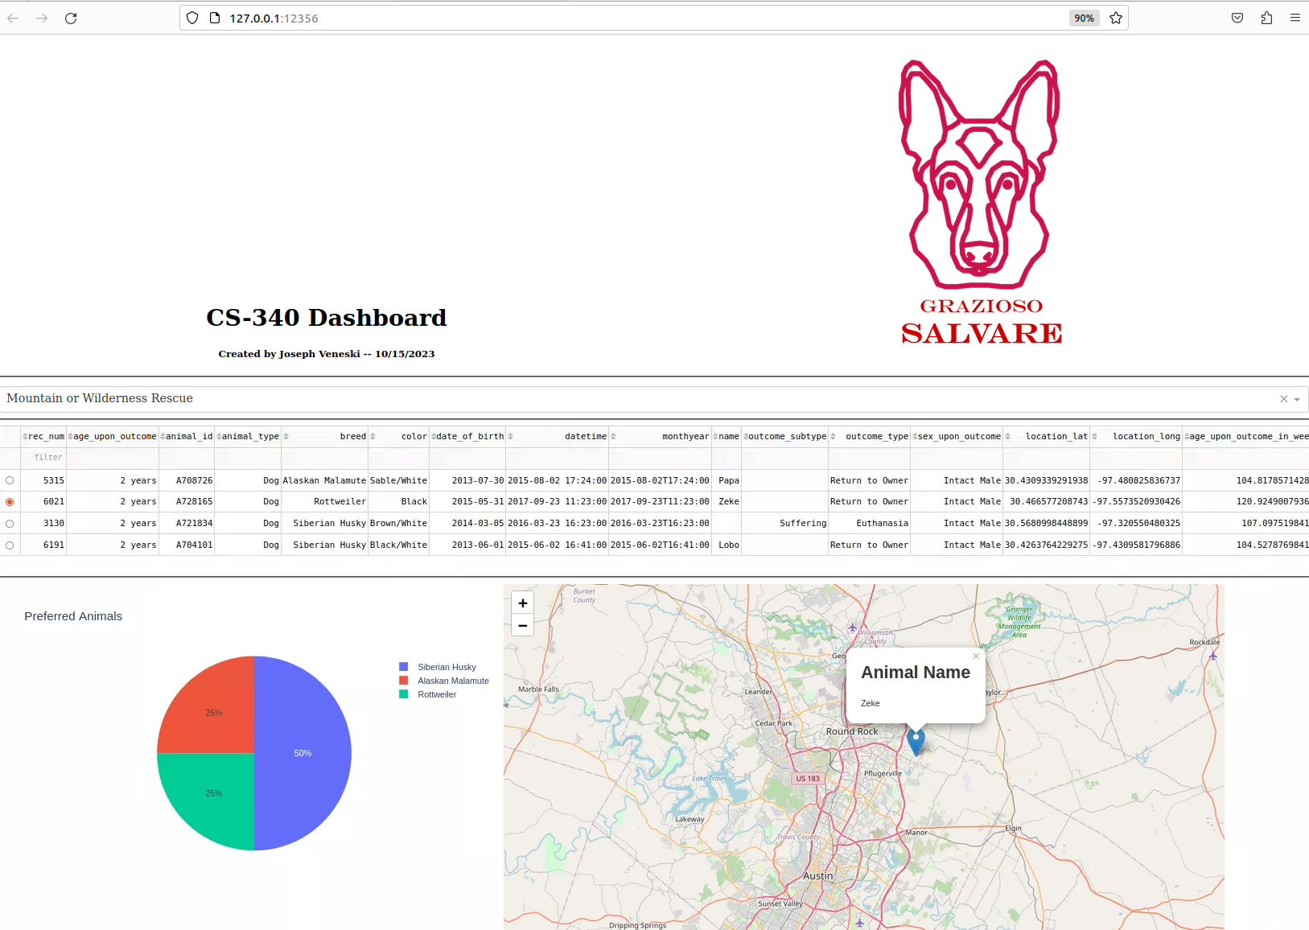

**Water Rescue Filter:**

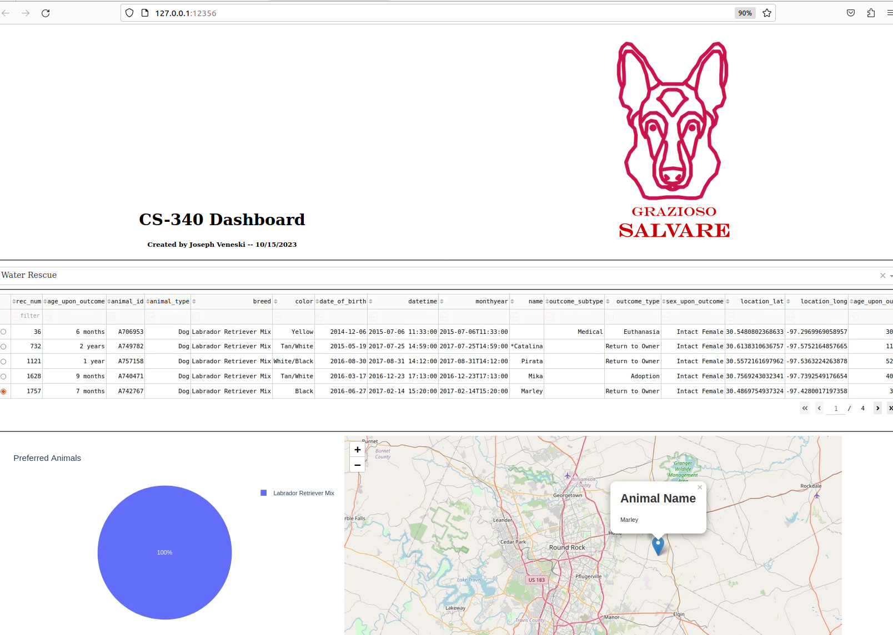

**Disaster or Individual Tracking Filter:**

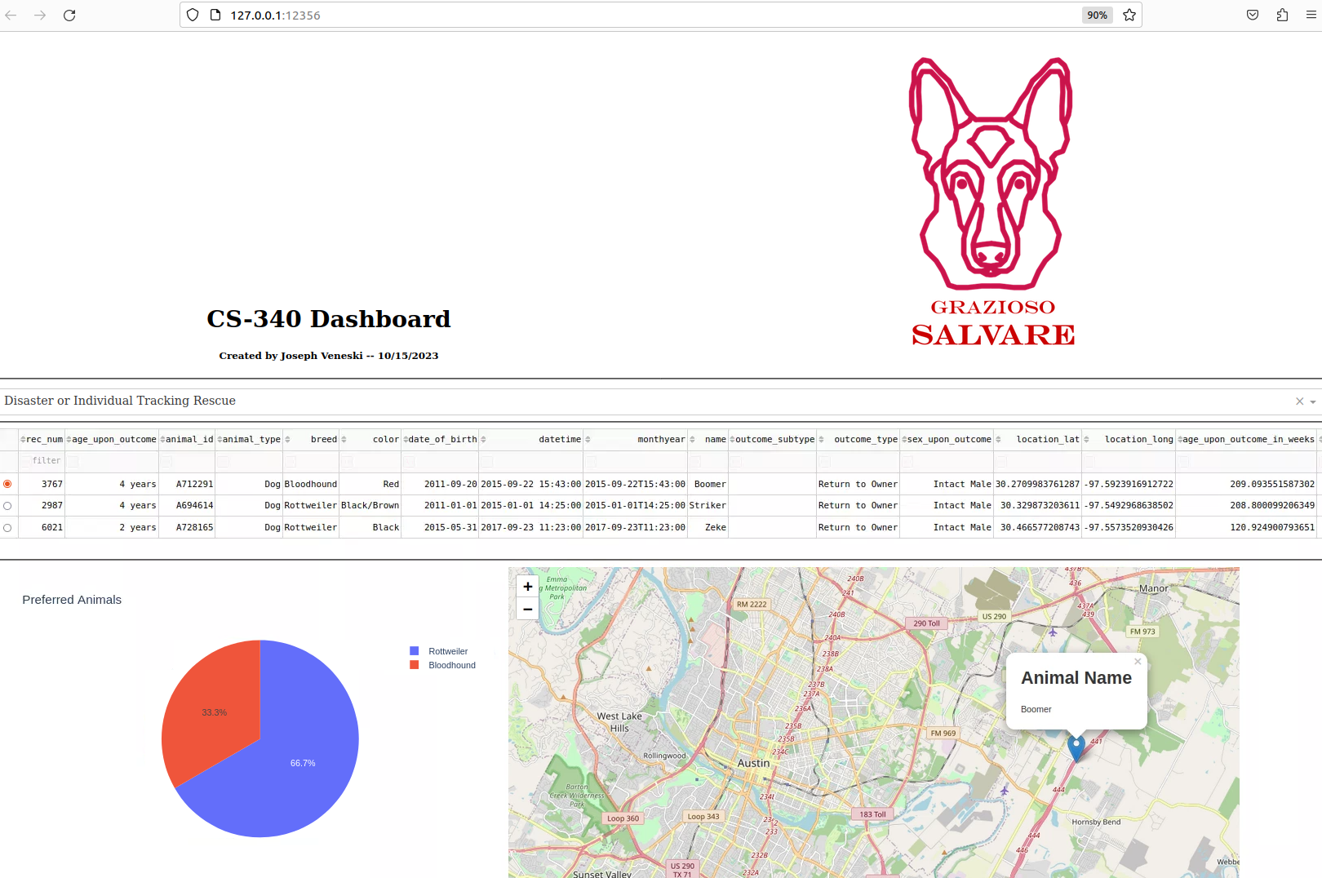

**Reset <un-filtered> Filter:**

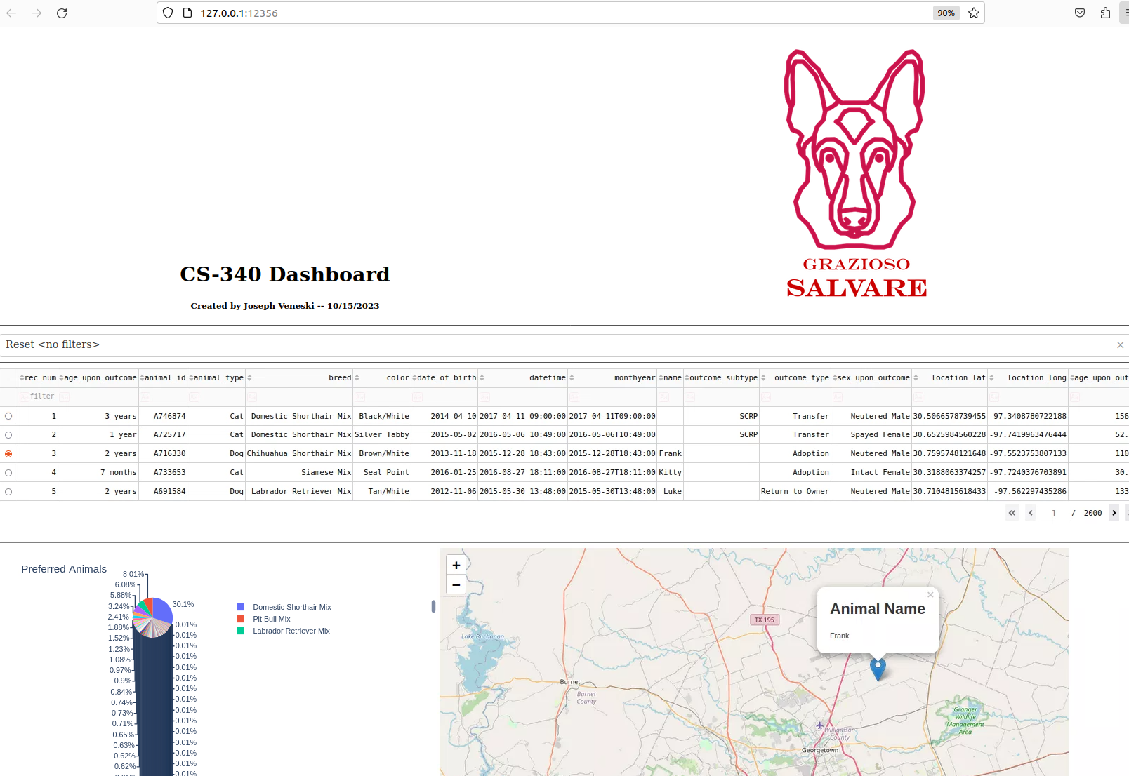

**Tools used:**

**-Python 3.9.12**

Python is used for writing the CRUD module and dashboard. Install Python via <https://www.python.org/downloads/>

**-MongoDB**

NoSQL database created using MongoDB. MongoDB is schema-less allowing for documents of various structures to be defined. This flexibility allows nesting attributes and indexing common queries (Giamas, 2022). MongoDB is actively supported and features a wide variety of tools to facilitate Python development, ideal for this project. MongoDB stores data in BSON format which interacts well with JSON based web applications. <https://www.mongodb.com/docs/manual/installation/>

**-PyMongo**

Official MongoDB driver for working with Python. Recommended installation through pip: *$ python3 -m pip install pymongo*

More information at <https://pymongo.readthedocs.io/en/stable/installation.html>

**-Jupyter Notebook**

Test script and dashboard written using Jupyter Notebook. Install Jupyter Notebook with pip: *pip install notebook* Documentation at <https://jupyter.org/install>

**-Dash**

Dash framework by Plotly is used to develop a dashboard with interactive widgets with Python code. This project makes use of the dropdown, geolocation, and graph components. Defining Dash callback functions in the dashboard allows full reactiveness to user inputs for components serving as the View and Controller of the MVC pattern. <https://dash.plotly.com/installation>

**-Pandas**

Open-source data analysis and manipulation tool used for visuals: <https://pandas.pydata.org/>

**Completing the Project:**

This project was completed in a Linux environment through a virtual lab in Apporto. Use the terminal to initialize the mongo shell. 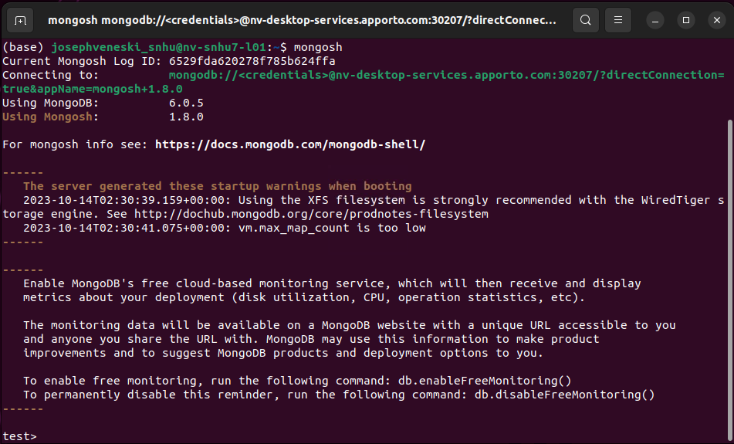 This project uses the “Austin Animal Center” (AAC) data set which can be imported using the following command: 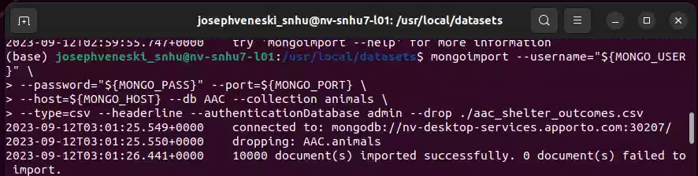 Port will vary so update for your environment accordingly: 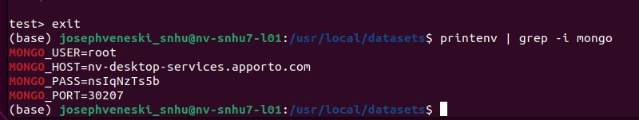Verification of successful import by using the find() command: 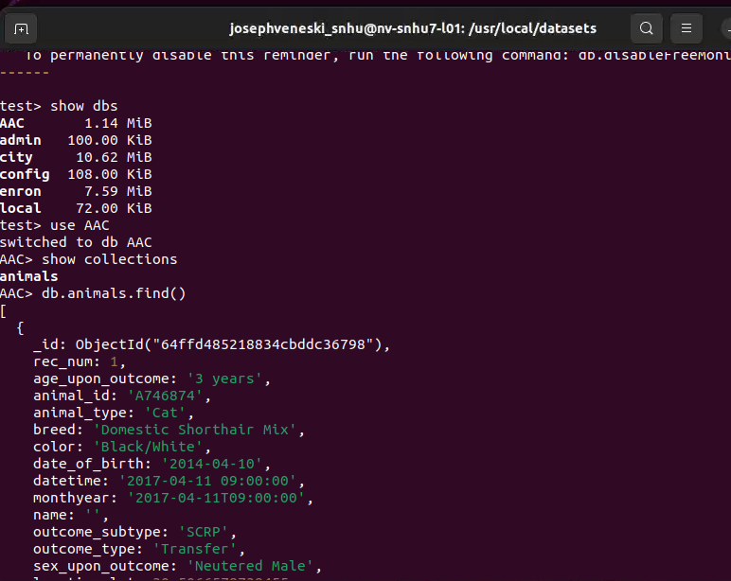

Create a *user* account in the ***admin*** database with read/write permission to the AAC database: 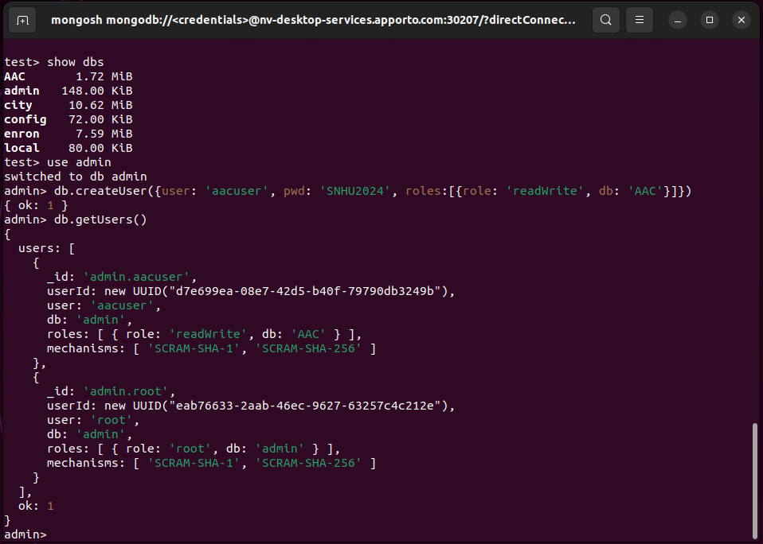

Verify successful access of user account to AAC database: 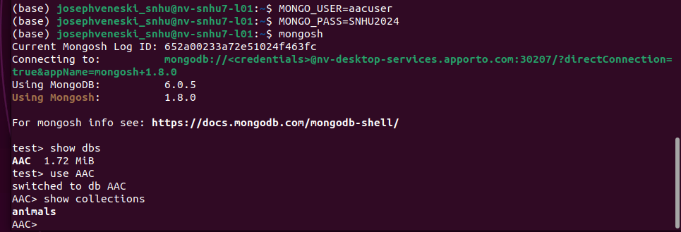

After establishing the database with MongoDB, a basic CRUD module was created in Python, *animalShelter.py,* and Jupyter notebook was used for creating a test script to verify CRUD functionality. CRUD operations require use of dictionary objects (key: value) pairs or errors will be thrown.: 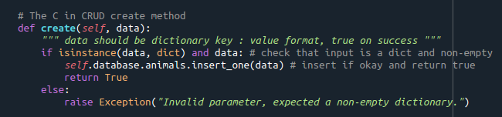

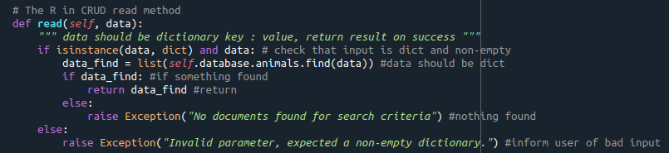

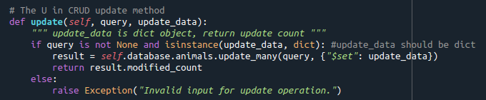

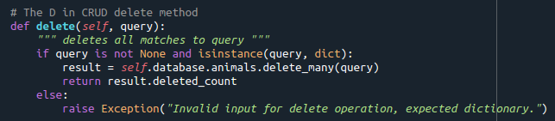

Test script:

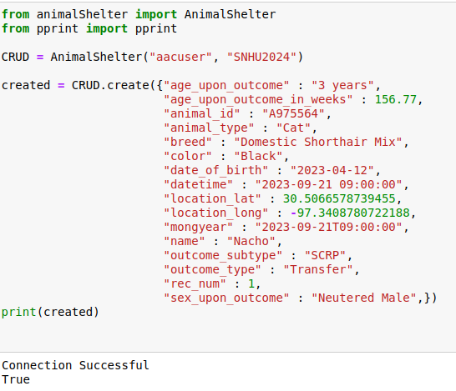

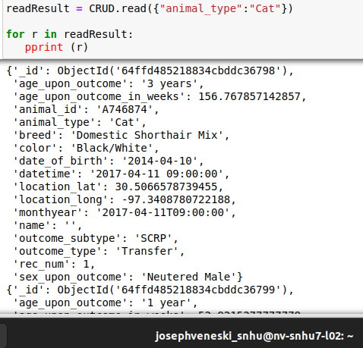

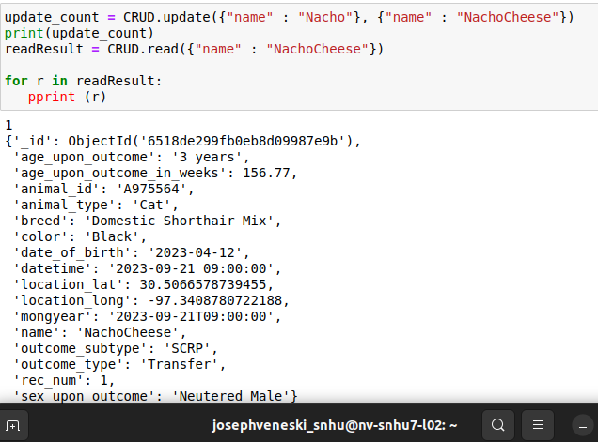

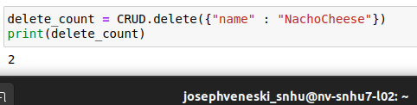

Example of error thrown for invalid input type: 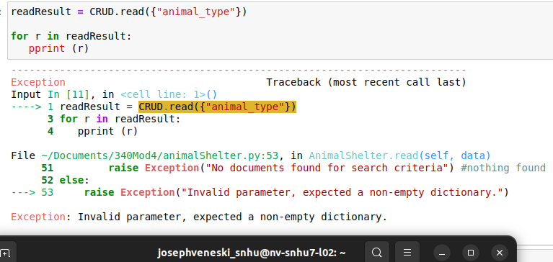

**Building the Dash dashboard:**

Using Python, we first establish a connection to the database and utilize the CRUD module just created to pull and unfiltered view of the AAC data set: 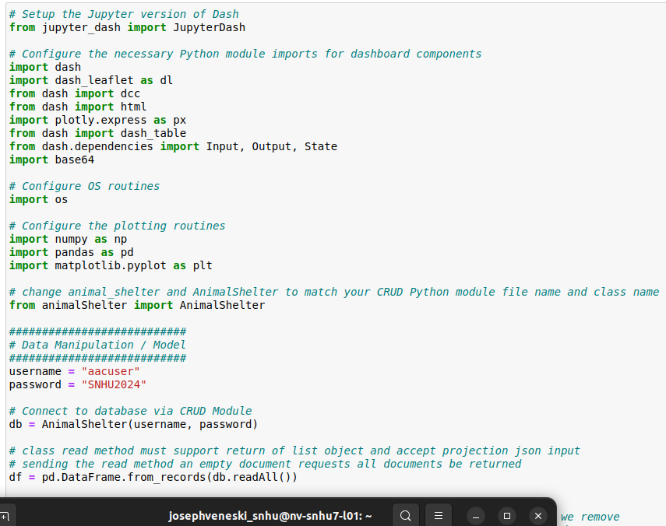

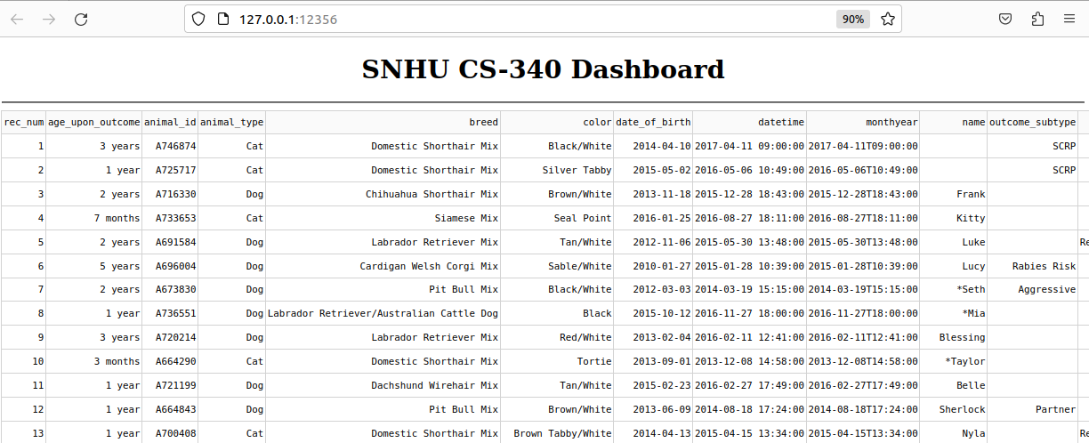

Next some basic native filtering was added with highlighting selected rows. 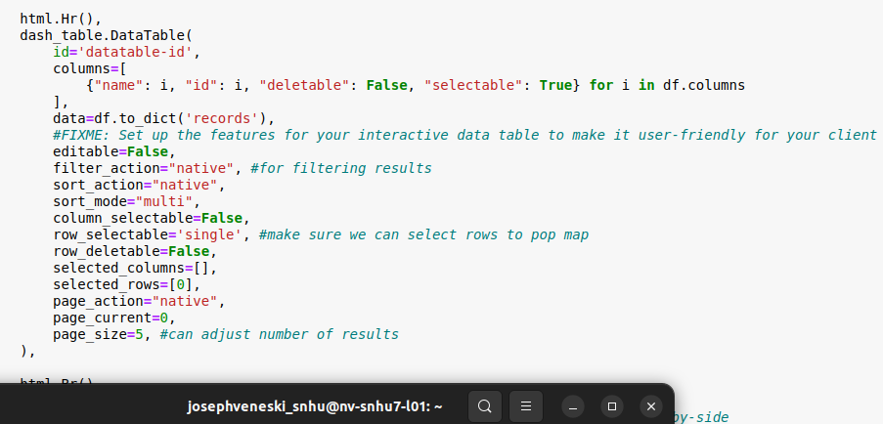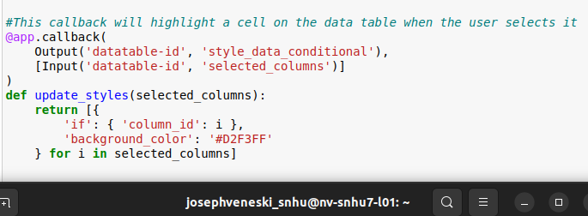

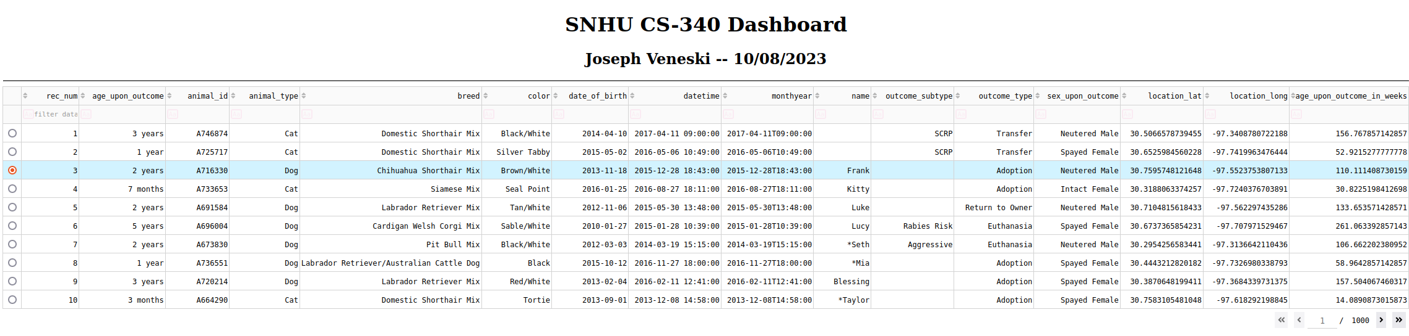

A geolocation chart component was added to the bottom of the dashboard with tooltip identifier that is reactive to selection in data set above: 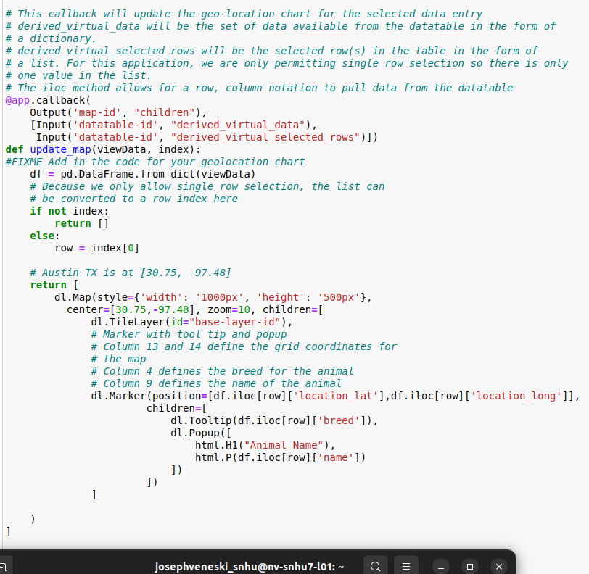

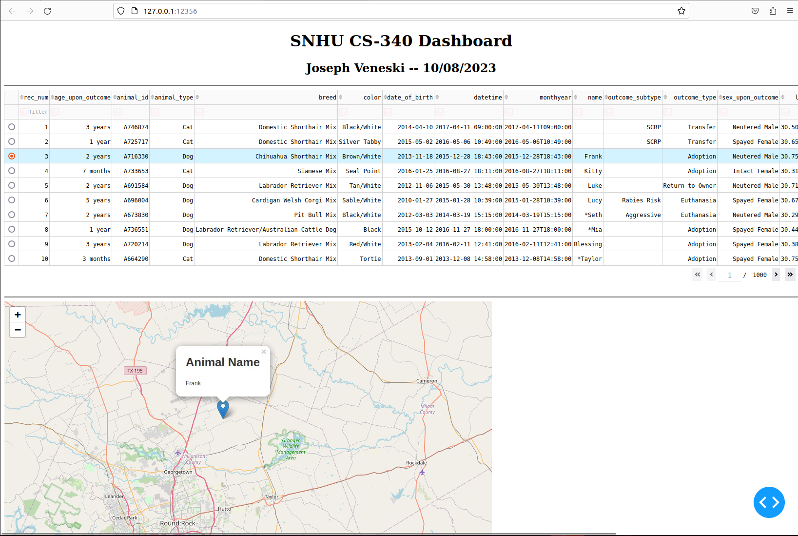

The client requested their image be displayed prominently at the top of the dashboard as well as credit to the author (unique identifier): 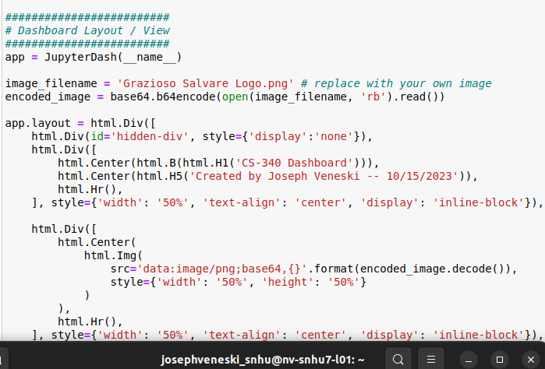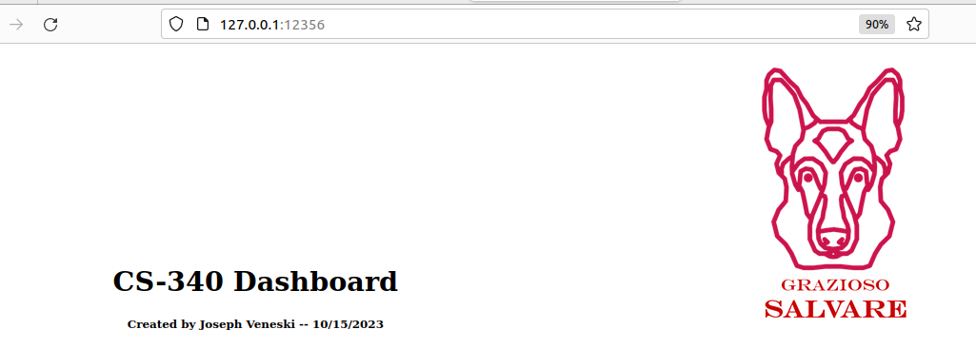

Next, a dropdown menu component was added to allow users to filter the data set by *Water Rescue, Mountain or Wilderness Rescue, Disaster or Individual Tracking Rescue,* or *Reset <unfiltered>*. The view of the data set and the geolocation chart are interactive with the dropdown filter. A pie-chart was added next to the geolocation chart as the final piece: 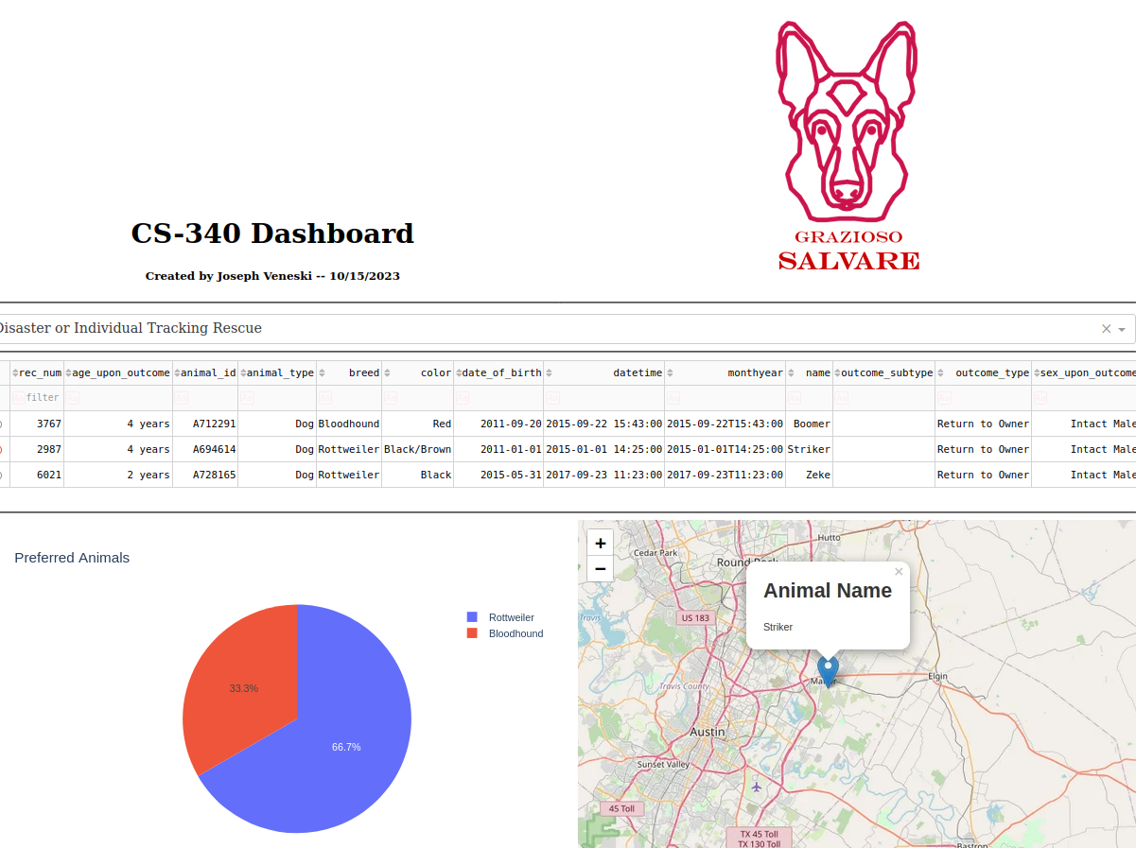

Snippet of dropdown: 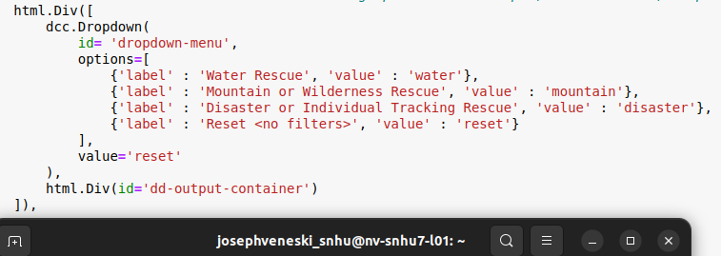

Snippet of custom queries for filters: 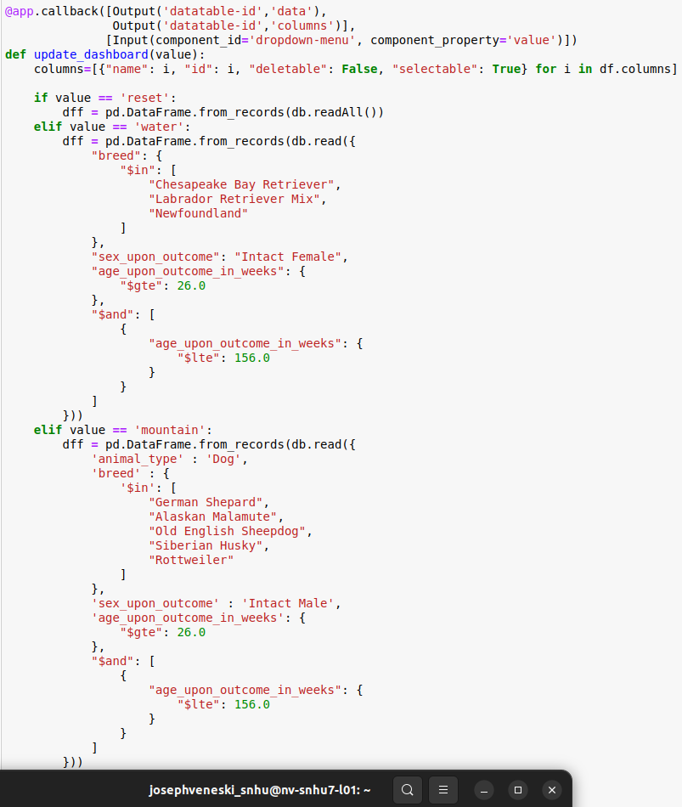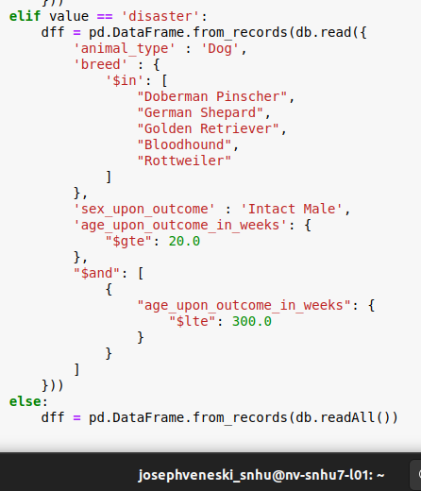

Snippet of pie-chart code: 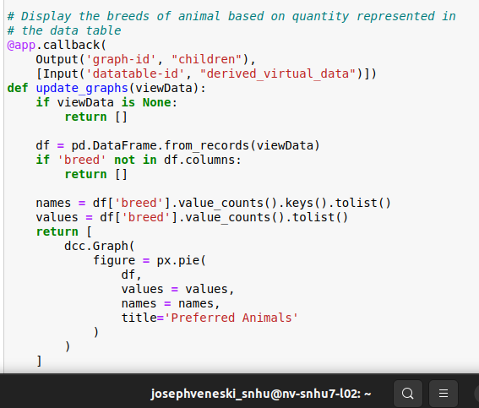

**Challenges Faced:**

This was the first time working with the Dash framework and required reading through the documentation to understand its function and how to use it. Writing or completing the starter code for the callbacks was made easy by referencing the guides on the Dash website. A dropdown menu was chosen as the ideal filter component to allow room for future filters to be added without risk of cluttering up the dashboard. Learning and utilizing new frameworks and tools will be a common practice in this field and this project was great practice. The project was also the first example of a full stack development project I have worked on and helped grow my understanding of client/server development.

**References:**

Alex Giamas. (2022). *Mastering MongoDB 6.x : Expert Techniques to Run High-volume and Fault-tolerant Database Solutions Using MongoDB 6.x: Vol. Third edition*. Packt Publishing.

 Austin Animal Center. (2020). *Austin Animal Center Outcomes* [Data set]. City of Austin, Texas Open Data Portal. <https://doi.org/10.26000/025.000001>

Plotly. (2023). *Basic Dash Callbacks*. <https://dash.plotly.com/basic-callbacks>